    Value for reflection: Generosity  “God Loves A Cheerful Giver” 2 Corinthians 9.7 |  |  | Spring 1 2024  "God gave you that gift...Now let it flourish, as a small flame grows into a fire"  2 Timothy 1: 6 (International Children's Bible)
Opening words/prayer:  We have gathered in the name of God the Father, Son and Holy Spirit to worship together and think about our value:  Generosity  Lighting of candle and welcome:  Teacher: May the peace of the Lord be always with you  All: And also with you.  Close of worship with the Lord’s Prayer, extinguish candle:  Teacher: Go in peace to love and serve the Lord  All: In the name of Christ Amen. | Hymns and songs to learn: |  | Epiphany - The Epiphany season is a liturgical period which immediately follows Christmas. It begins on Epiphany Day, and ends at various points as defined by different denominations, in the Anglican church it is at the start of February. The typical liturgical color for the day of Epiphany is white, and the typical color for Epiphany season is green.  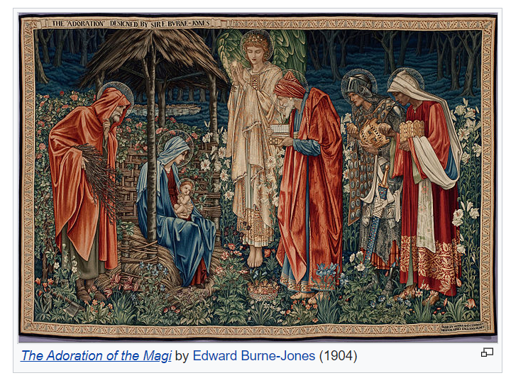  Generosity of Spirit  Helping others  Giving
 | Key Stage 1  BBC Radio songs-for-collective-worship  - Give me oil in my lamp  - Move when the Spirit Says Move  - Reduce, Reuse Recycle  - Stop and Think! | Key Stage 2  BBC Radio songs-for-collective-worship  - All things Bright and Beautiful  - For the Beauty of the Earth  - Can you feel the Love tonight? – The Lion King  - Help! - The Beetles

Monday | Tuesday | Wednesday | Thursday | Friday
08  Value Based Worship - Generosity  Phase Led Worship – Rota  Page 13 Roots and Fruits  Loving others as we love ourselves – the story of Johnny Appleseed  Roots and Fruits Generosity | 09  Singing Worship  Led by Deb | 10  Secular Story about Generosity  Led by Cath   | 11  Picture News Worship  Follow up with activities from slides including Protected Characteristics and British Values. | 12  Celebrating Our Children  Star Learners and Celebration Worship  https://www.picture-news.co.uk  The resource emails will arrive every Friday morning (term time) ready for the week ahead.  You can also now access historical packs and PowerPoints to download from our site here:  - Login URL : www.picture-news.co.uk/users  - Username : clee@allsaintsfed.derbyshire.sch.uk  - Password : picturenews  - Packs will be in date order, you can search by a key word and download parts or the whole pack as required
15  Fr Richard leading worship.  ASJuniors 9am | 16  Fr Richard leading worship AS Infants 2pm  Singing Worship  Led by Deb | 17  Secular Story about Generosity  Led by Cath   | 18  Picture News Worship  Follow up with activities from slides including Protected Characteristics and British Values. | 19  Celebrating Our Children  Star Learners and Celebration Worship
22  ASJuniors Open the Book 2.55pm  Value Based Worship - Generosity  Page 16 Roots and Fruits  Giving Sacrificially  The Generous Widow  Roots and Fruits Generosity | 23  Singing Worship  Led by Deb  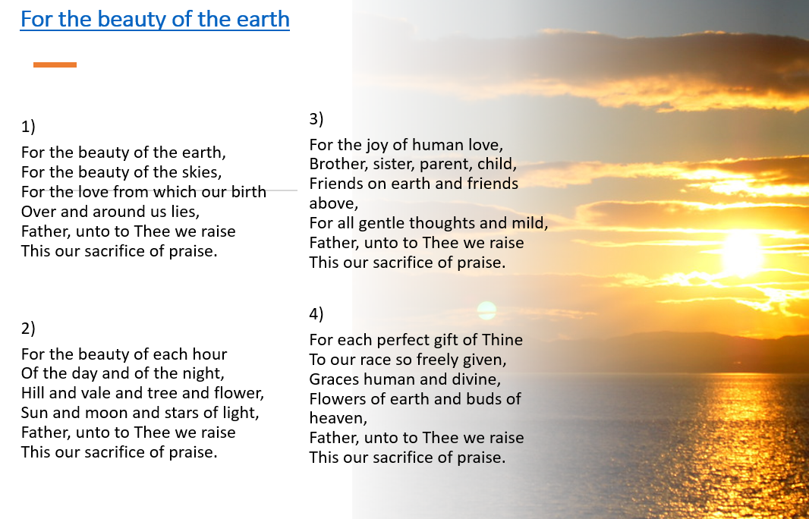 | 24  ASInfants Open the Book. 1.45pm  Secular Story about Generosity  Led by Cath  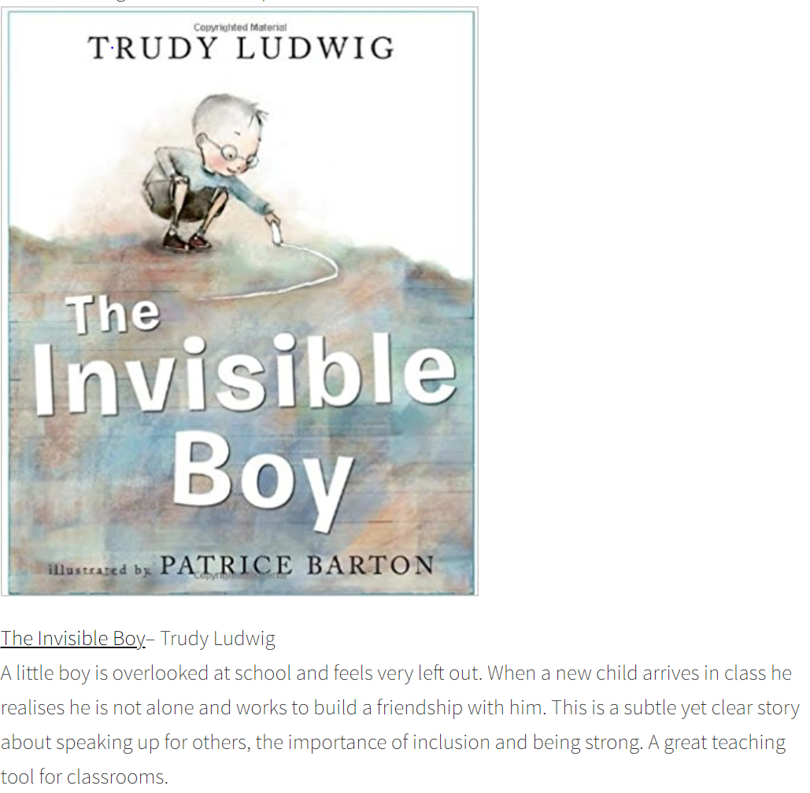 | 25  Picture News Worship  Follow up with activities from slides including Protected Characteristics and British Values. | 26  Celebrating Our Children  Star Learners and Celebration Worship
29  Value Based Worship - Generosity  Phase Led Worship – Rota  Page 19 Roots and Fruits  Giving Cheerfully  Freddie’s Sponsored Ride  Roots and Fruits Generosity | 30  MAST – Moses 10.15am | 31  Secular Story about Generosity  Led by Cath  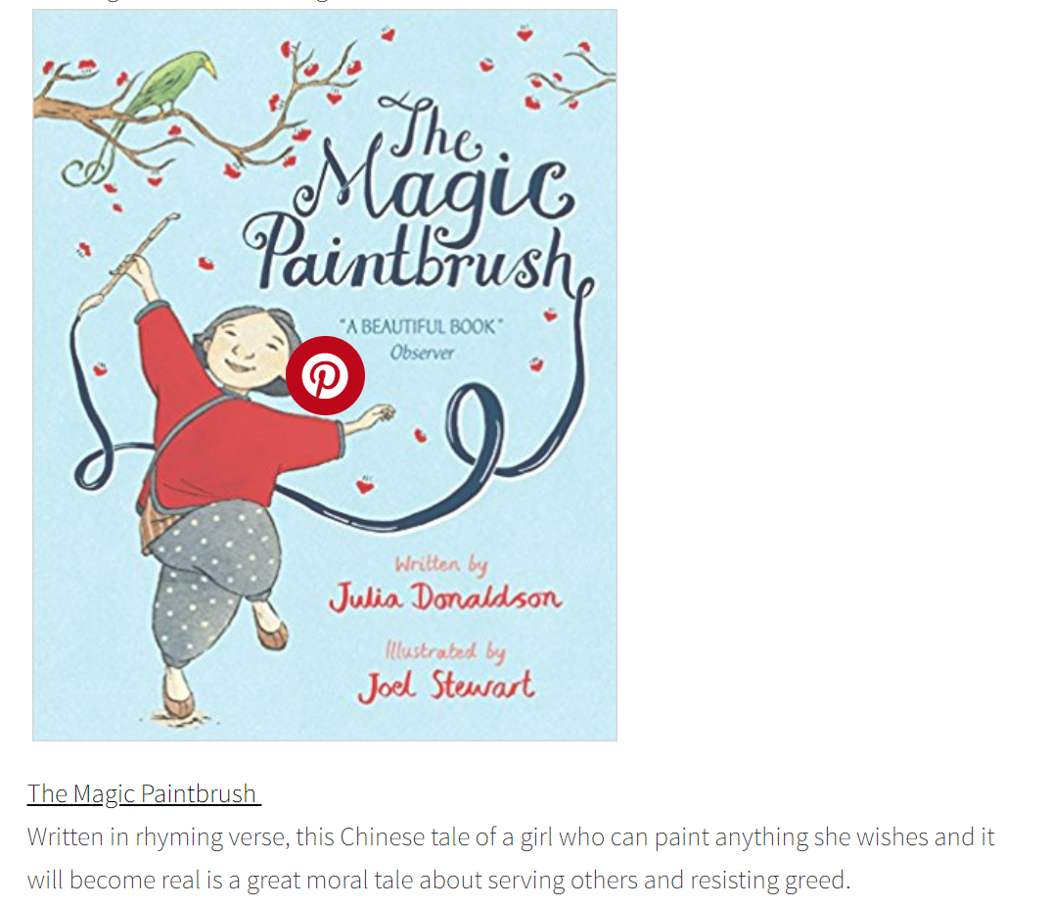 | 01  Picture News Worship  Follow up with activities from slides including Protected Characteristics and British Values. | 02  Celebrating Our Children  Star Learners and Celebration Worship
Value Based Worship - Generosity  Page 22 Roots and Fruits  Caring for Creation  A World of Wonders  Roots and Fruits Generosity | 06  Singing Worship  Led by Deb   | 07  Secular Story about Generosity    Led by Cath | 08  Picture News Worship  Follow up with activities from slides including Protected Characteristics and British Values. | 09  Chinese New Year  Celebrating Our Children  Star Learners and Celebration Worship
12  Fr Richard leading worship ASJuniors 9am  Value Based Worship - Generosity  Page 25 Roots and Fruits  Giving our Time  Barney and Bella  Roots and Fruits Generosity | 13  Singing Worship  Led by Deb  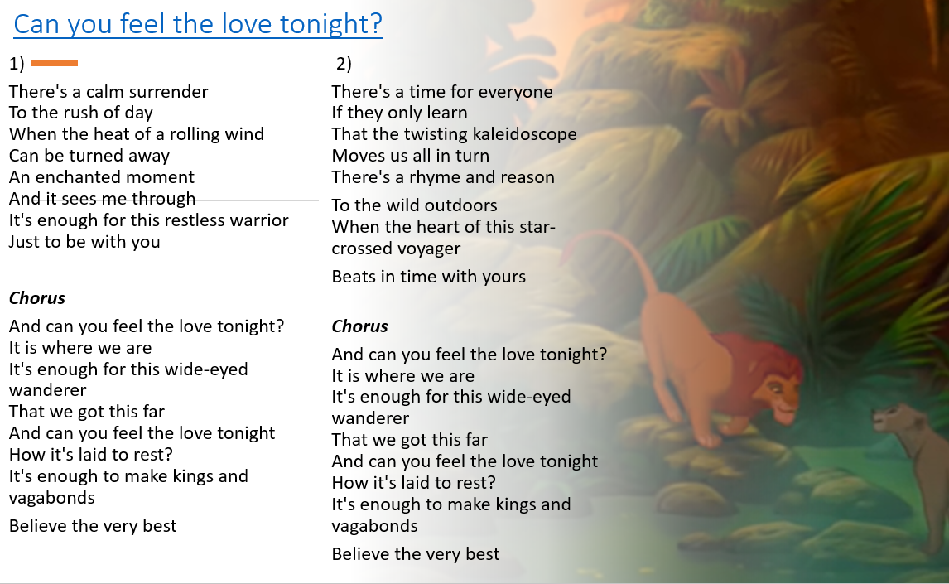 | 14  Ash Wednesday  Secular Story about Generosity    Led by Cath | 15  Picture News Worship  Follow up with activities from slides including Protected Characteristics and British Values. | 16  Celebrating Our Children  Star Learners and Celebration Worship

