Value for reflection: Thankfulness  ‘Always be thankful.’  Thessalonians 5.16 |  |  | Autumn 1 2023
Opening words/prayer:  We come together in the name of: God the Father who gives us all the things to enjoy, God the Son who loves the world and all the people in it, and God the Holy Spirit who gives us the spirit of thankfulness.  Lighting of candle and welcome:  Teacher: May the peace of the Lord be always with you  All: And also with you.  Close of worship with the Lord’s Prayer, extinguish candle:  Teacher: Go in peace to love and serve the Lord  All: In the name of Christ Amen. | Hymns and songs to learn  (including preparation for Harvest Festival services) |  | Welcoming  Settling in and helping others  Gratitude
 | Key Stage 1  - Our God is a great big God  - Who put the colours in the rainbow  - Thank you Lord for this new day  - All things bright and beautiful  - If I were a Butterfly | Key Stage 2  - Who put the colours in the rainbow  - Think of a world without any flowers  - How great thou art  - Thank you Lord for this new day  - If I were a Butterfly | Welcoming  Settling in and helping others  Gratitude

Monday | Tuesday | Wednesday | Thursday | Friday
04  INSET. | 05  INSET | 06  Welcome to the New School Year. | 07  Picture News Worship  Follow up with activities from slides including Protected Characteristics and British Values. | 08  Celebration Assembly  Celebration of our children’s achievements during their week.
11  Roots and Fruits  Page 137  Bible Verse: Philippians 1:3 | 12  Singing Worship | 13  Stories that show Thankfulness  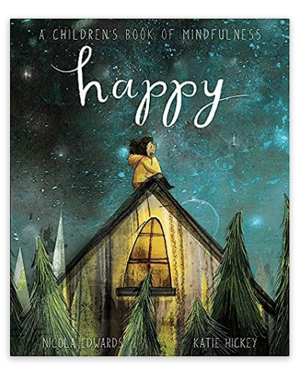 | 14  Picture News Worship  Follow up with activities from slides including Protected Characteristics and British Values. | 15  Celebration Assembly  Celebration of our children’s achievements during their week.
18  Roots and Fruits  Page 140  Bible Verse Psalm 148 | 19  ASJuniors Singing Worship  ASInfants MAST  Tuesday 19th September at 1.45pm – Abraham & Sarah | 20  Stories that show Thankfulness  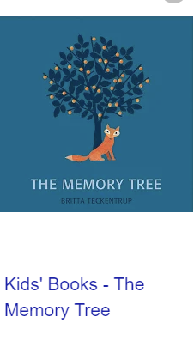 | 21  Picture News Worship  Follow up with activities from slides including Protected Characteristics and British Values. | 22  Celebration Assembly  Celebration of our children’s achievements during their week.
25  ASJuniors Open the Book  ASInfants Roots and Fruits  Page 143  Bible Verse: Ephesians 5:20 | 26  ASInfants Singing Worship  ASJuniors MAST  Tuesday 26th September at 10.15am – David the Shepherd (Psalm 23) | 27  Stories that show Thankfulness   | 28  Picture News Worship  Follow up with activities from slides including Protected Characteristics and British Values. | 29  Celebration Assembly  Celebration of our children’s achievements during their week.
02    Roots and Fruits  Page 146  Bible Verse: Acts 16:16-End | 03  Singing Worship | 04  Stories that show Thankfulness | 05  Picture News Worship  Follow up with activities from slides including Protected Characteristics and British Values. | 06  Celebration Assembly  Celebration of our children’s achievements during their week.
09  Roots and Fruits  Page 149  Bible Verse: 1 Thessalonians 5:16 | 10  Singing Worship | 11  Stories that show Thankfulness  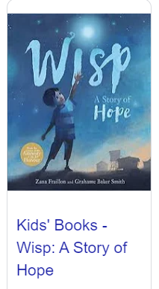 | 12  Picture News Worship  Follow up with activities from slides including Protected Characteristics and British Values. | 13  Celebration Assembly  Celebration of our children’s achievements during their week.
16  Roots and Fruits  Page 152  Bible Verse: Mark 4:3-9  Linked to Harvest Festival | 17  Singing Worship | 18  Stories that show Thankfulness  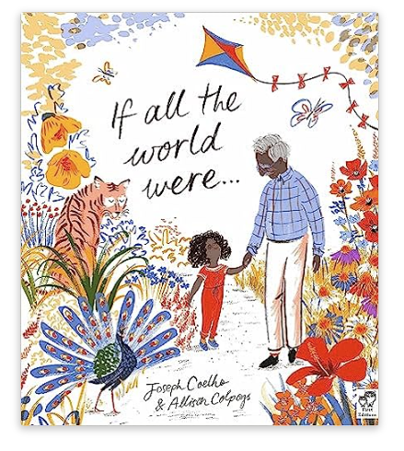 | 19  Picture News Worship  Follow up with activities from slides including Protected Characteristics and British Values. | 20  Celebration Assembly  Celebration of our children’s achievements during their week.
23  Giving Thanks for Harvest  (This may come earlier in order to link with local Church and Food Bank Donations) | 24  AS Infants Singing Worship  ASJuniors MAST  Tuesday 24th October at 10.15am – Isaiah (prophecies about Jesus) | 25  Stories that show Thankfulness  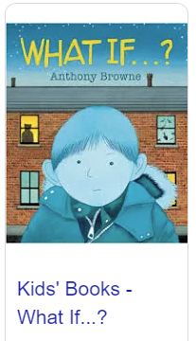 | 26  Picture News Worship  Follow up with activities from slides including Protected Characteristics and British Values. | 27  Celebration Assembly  Celebration of our children’s achievements during their week.

